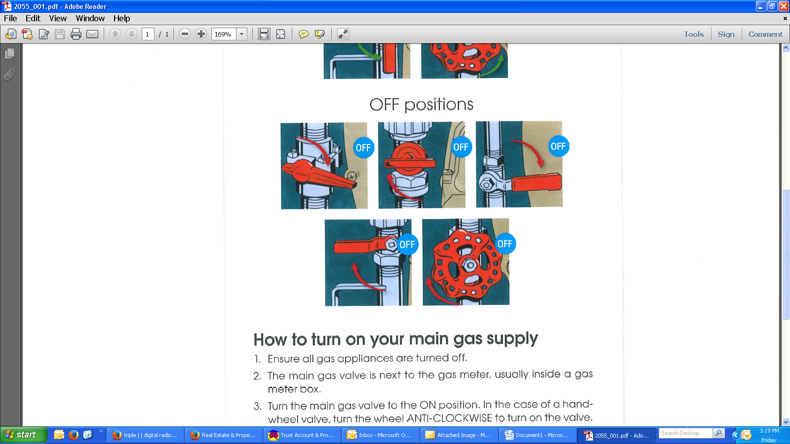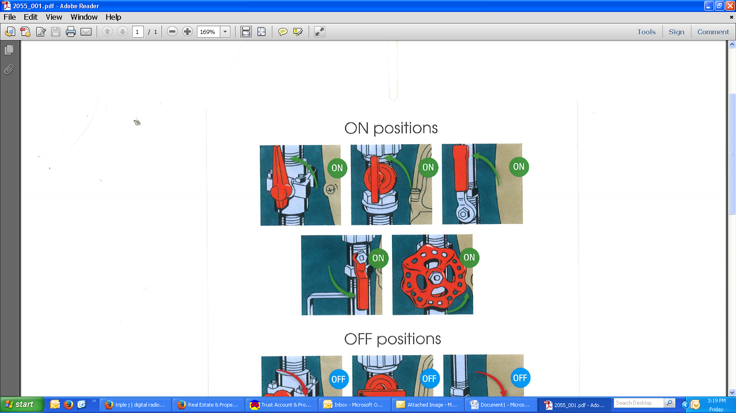

***How to turn on your main gas supply***

1. Ensure all gas appliances are turned OFF
2. The main gas valve is next to the gas meter, usually inside a gas metre box.
3. Turn the main gas valve to the ON position. In the case of a hand-wheel valve, turn the when ANTI-CLOCKWISE to turn on the valve.
4. The dial of indicator on top of the gas meter may move but should stop within a few seconds. Relight the pilot light following manufacture’s instruction. Your gas appliances are now ready for use.

***As a new gas account has not yet been established for these premises if you are a new tenant please contact Alinta energy on 13 13 58.***